Title: Effect of interindividual variability in metabolic clearance and relative bioavailability on rifampicin exposure in tuberculosis patients with and without HIV co-infection: does formulation quality matter?

**SUPPLEMENT**

Analytical method for analysis of rifampicin and 25-O-desacetyl-rifampicin in plasma

A liquid chromatography-tandem accurate mass spectrometry (LC-MS/MS) method was developed and validated to quantify rifampicin, 25-O-deacetyl-rifampicin in plasma with low limits of quantification. Full details of the method development and validation are described previously [1]. The coefficients of variation (CV) and relative standard errors (RSE) of intra-and inter-assay precision and accuracy were lower than 15%. Analytical linearity range of RIF and desRIF were 1.22–5000 and 1.95–1000 ng/ml (lower limit of quantification to upper boundary).

DNA extraction and genotyping of OATP1B1

Genomic DNA was extracted from whole blood using chaotropic salting out standard procedures. Taqman SNP genotyping assays and a Fast 7500 Real-Time System (Applied Biosystems, Foster City, CA, USA) were used for allele discrimination at the polymorphic loci of *SLCO1B1*: g.521T>C (rs4149056), g.463C>A (rs11045819), g.38664C>T (rs4149032) [2]. Allele and genotype frequency were derived by gene counting.

Model qualification

The goodness of fitting plots (GOF)[3,4] includes plots of the population predicted (PRED) and individual predicted (IPRED) concentrations versus the observed concentrations, and the conditional weighted residuals (CWRES) versus PRED and time (Figure S1).

Visual predictive check (VPC)[3–5], Posterior predictive check (PPC)[6] and normalised predictive distribution errors (NPDE)[7] were obtained from 1000 simulations of plasma concentrations from 0 to 24 h for individual subjects with the same demographic characteristics, dosing regimens and sampling schedule as in the original clinical data. The VPCs are presented in the manuscript as Figure 3.

In addition, PPC was performed using the area under the plasma concentration vstime curve from 0-24h (AUC0-24) and maximum plasma concentration (Cmax) as measures of model performance. Predicted and observed AUC0-24 (trapezoidal method) and Cmax values were calculated non-compartmentally. The simulated AUC0-24 and Cmax histograms are presented along with the median, 5th and 95th percentiles of observed AUC0-24 and Cmax (Figure S2).

NPDEs were calculated using the ‘npde’ package v.2.0 in R to assess general model performance in subsequent simulations. The NPDE results were summarised graphically in (i) QQ-plot of the NPDE; (ii) histogram of the NPDE; (iii) NPDE versus time and (iv) NPDE versus predicted concentrations. The NPDE is expected to follow a N (0-1) distribution (Figure S3).

These results were complemented by mirror plots, which were generated in PsN. Mirror plots were aimed at assessing the degree of similarity across observed and simulated concentration vs. time profiles (Figure S4).

**Figure S1:** Goodness of fit plots (GOF) of rifampicin (RIF) and 25-O-deacetyl-rifampicin (desRIF) by the final model. Observed concentrations (g/mL) over population and individual predictions (right). Conditional weighted residuals (CWRES) over population predictions and time (left). Red line: trend line, dashed lines in right plots: identity, and 2- and 0.5-times identity. Dashed lines in left plots: -2, 0 and 2 CWRES

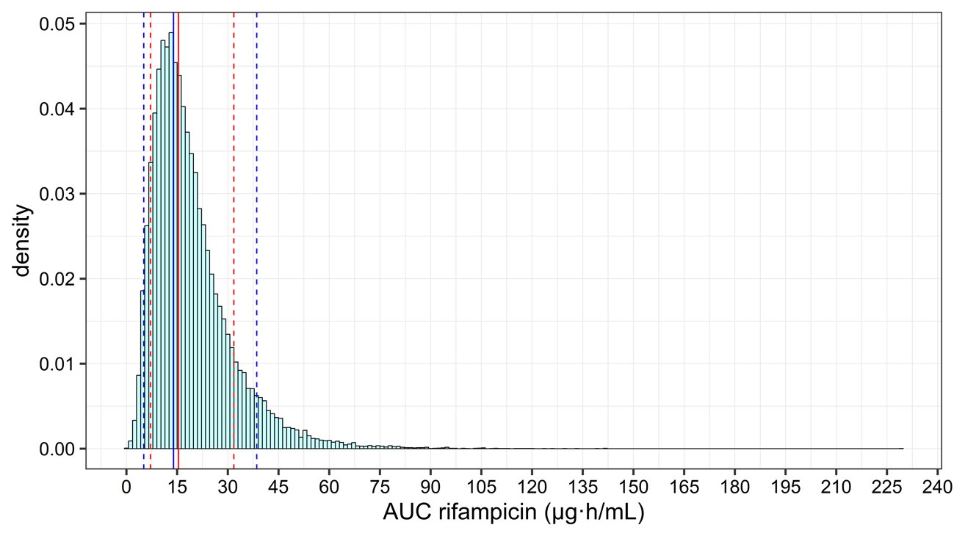

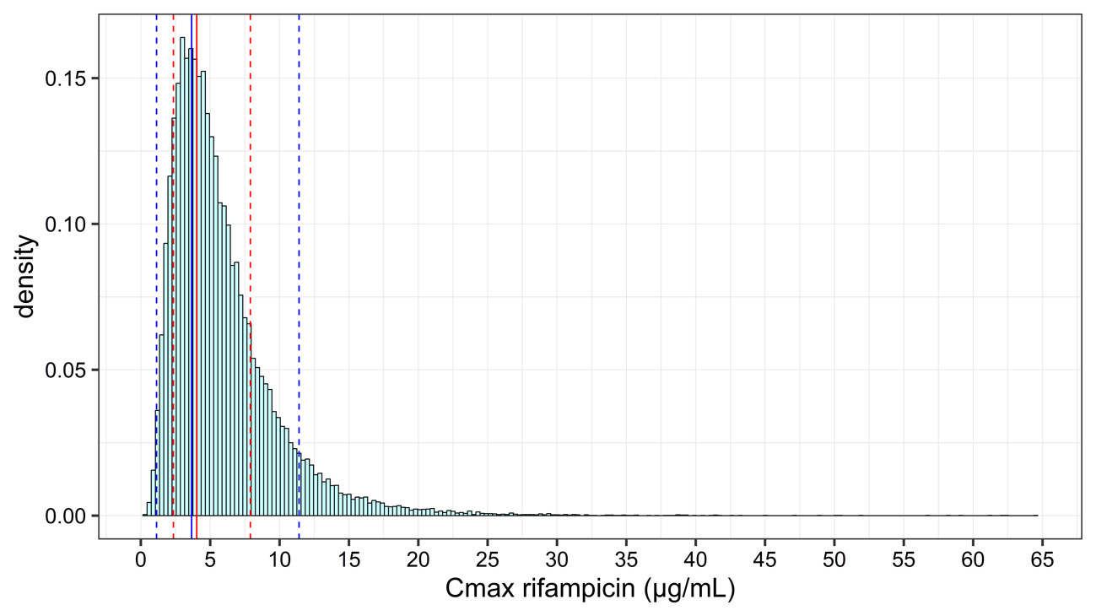

**Figure S2:** Posterior predictive check (PPC) of rifampicin pharmacokinetics model. Frequency histograms show the predicted distribution of simulated AUC0–24 and Cmax values (n = 1000 simulations). Red lines: 5%, 50% and 95% quantiles of observed AUC0–24 and Cmax. Blue lines: 5%, 50% and 95% quantiles of individual predicted AUC0–24 and Cmax.

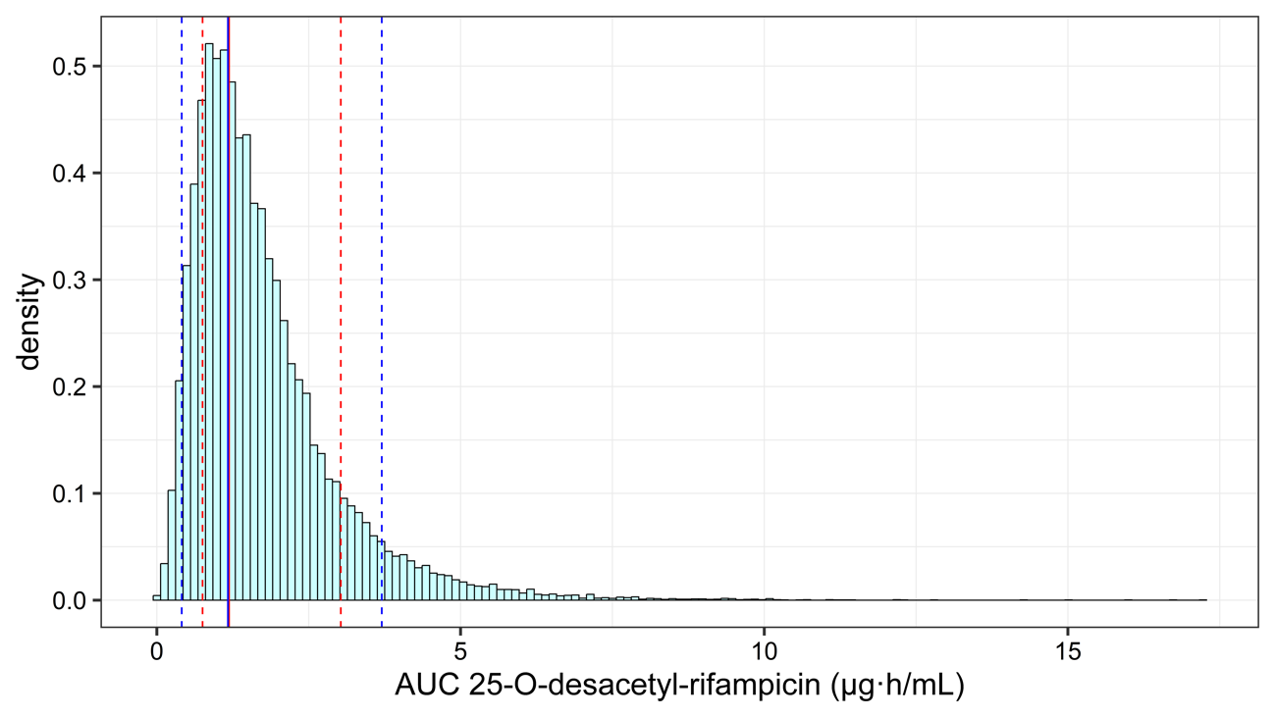

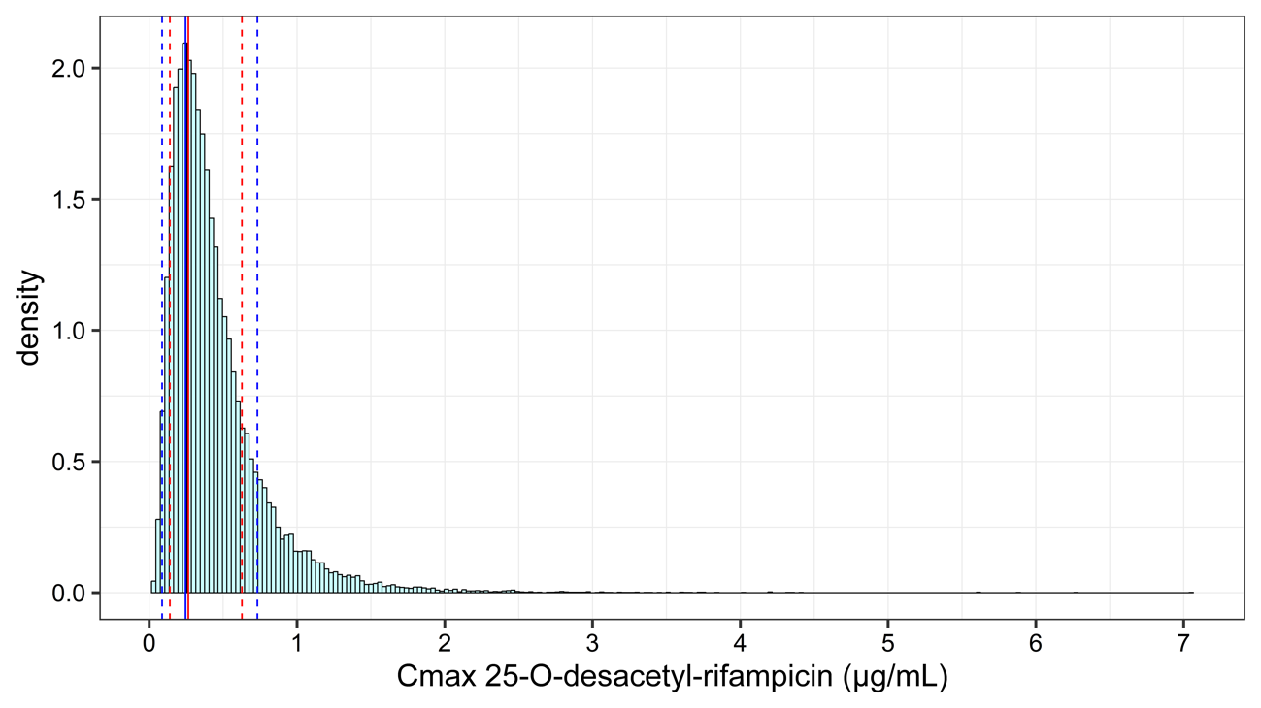

**Figure S2 (continuation)**: Posterior predictive check (PPC) of 25-O-desacetyl-rifampicin pharmacokinetics model. Frequency histograms show the predicted distribution of simulated AUC0–24 and Cmax values (n = 1000 simulations). The red lines depict the 5%, 50% and 95% quantiles of observed AUC0–24 and Cmax; and blue lines depict the 5%, 50% and 95% quantiles of individual predicted AUC0–24 and Cmax.

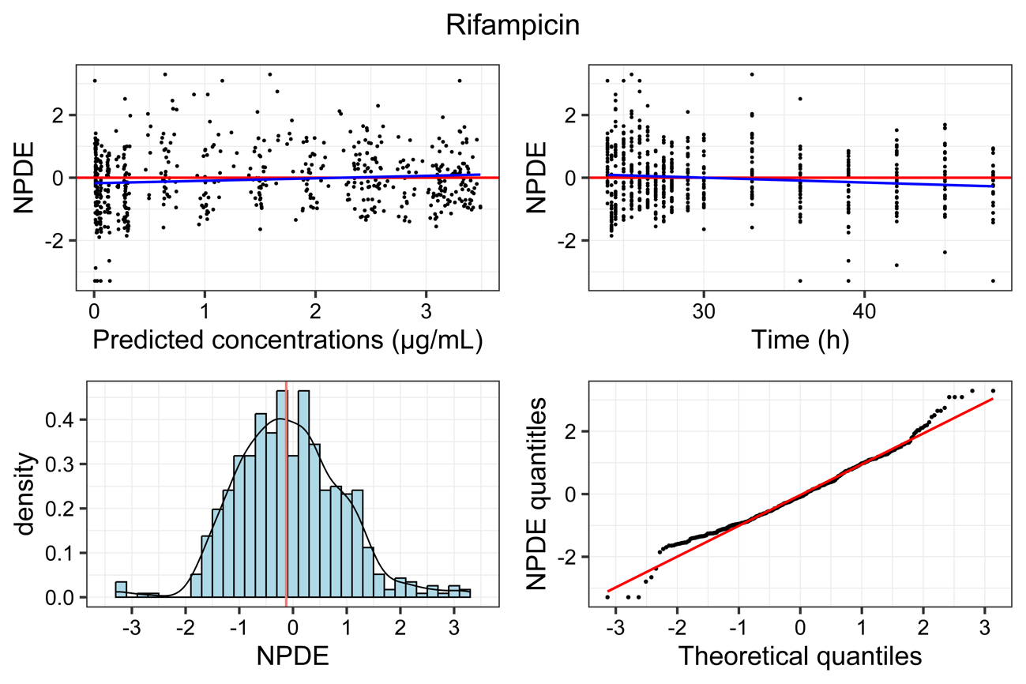

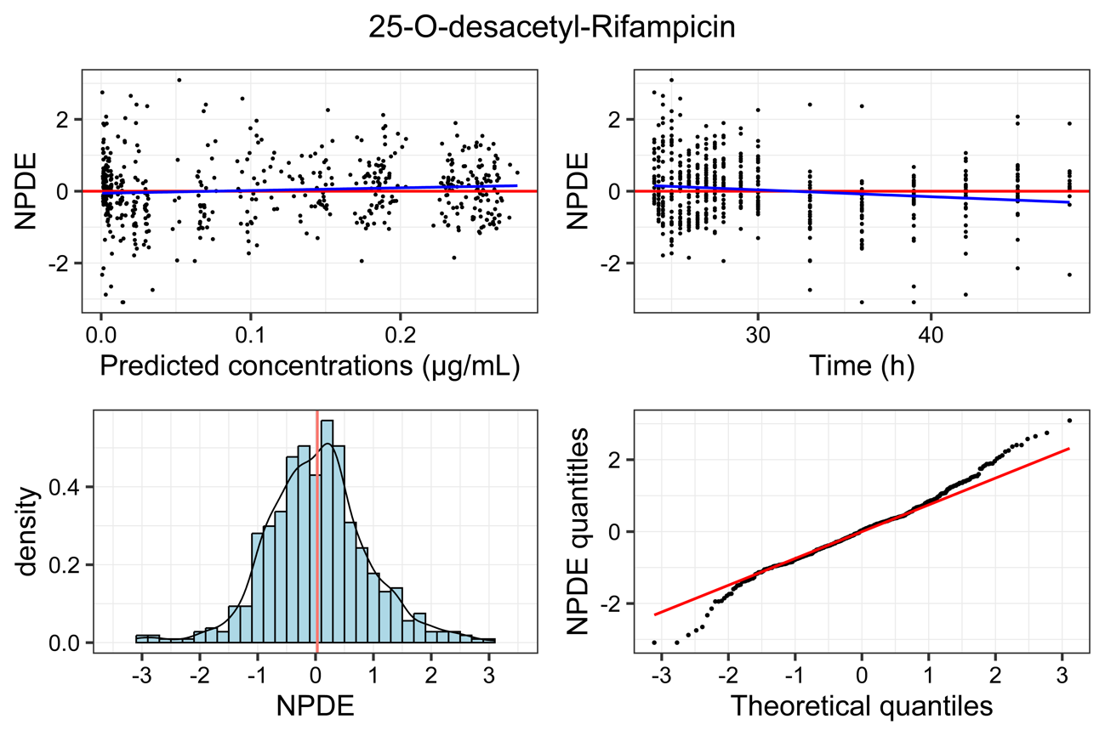

**Figure S3:** Normalised predictive distribution errors (NPDE) of rifampicin and 25-O-desacetly-rifampicin pharmacokinetics model. NPDE vs predicted concentrations (top left) and time (top right). NPDE histogram (bottom left) NPDE normal quantile – quantile plot (bottom right).

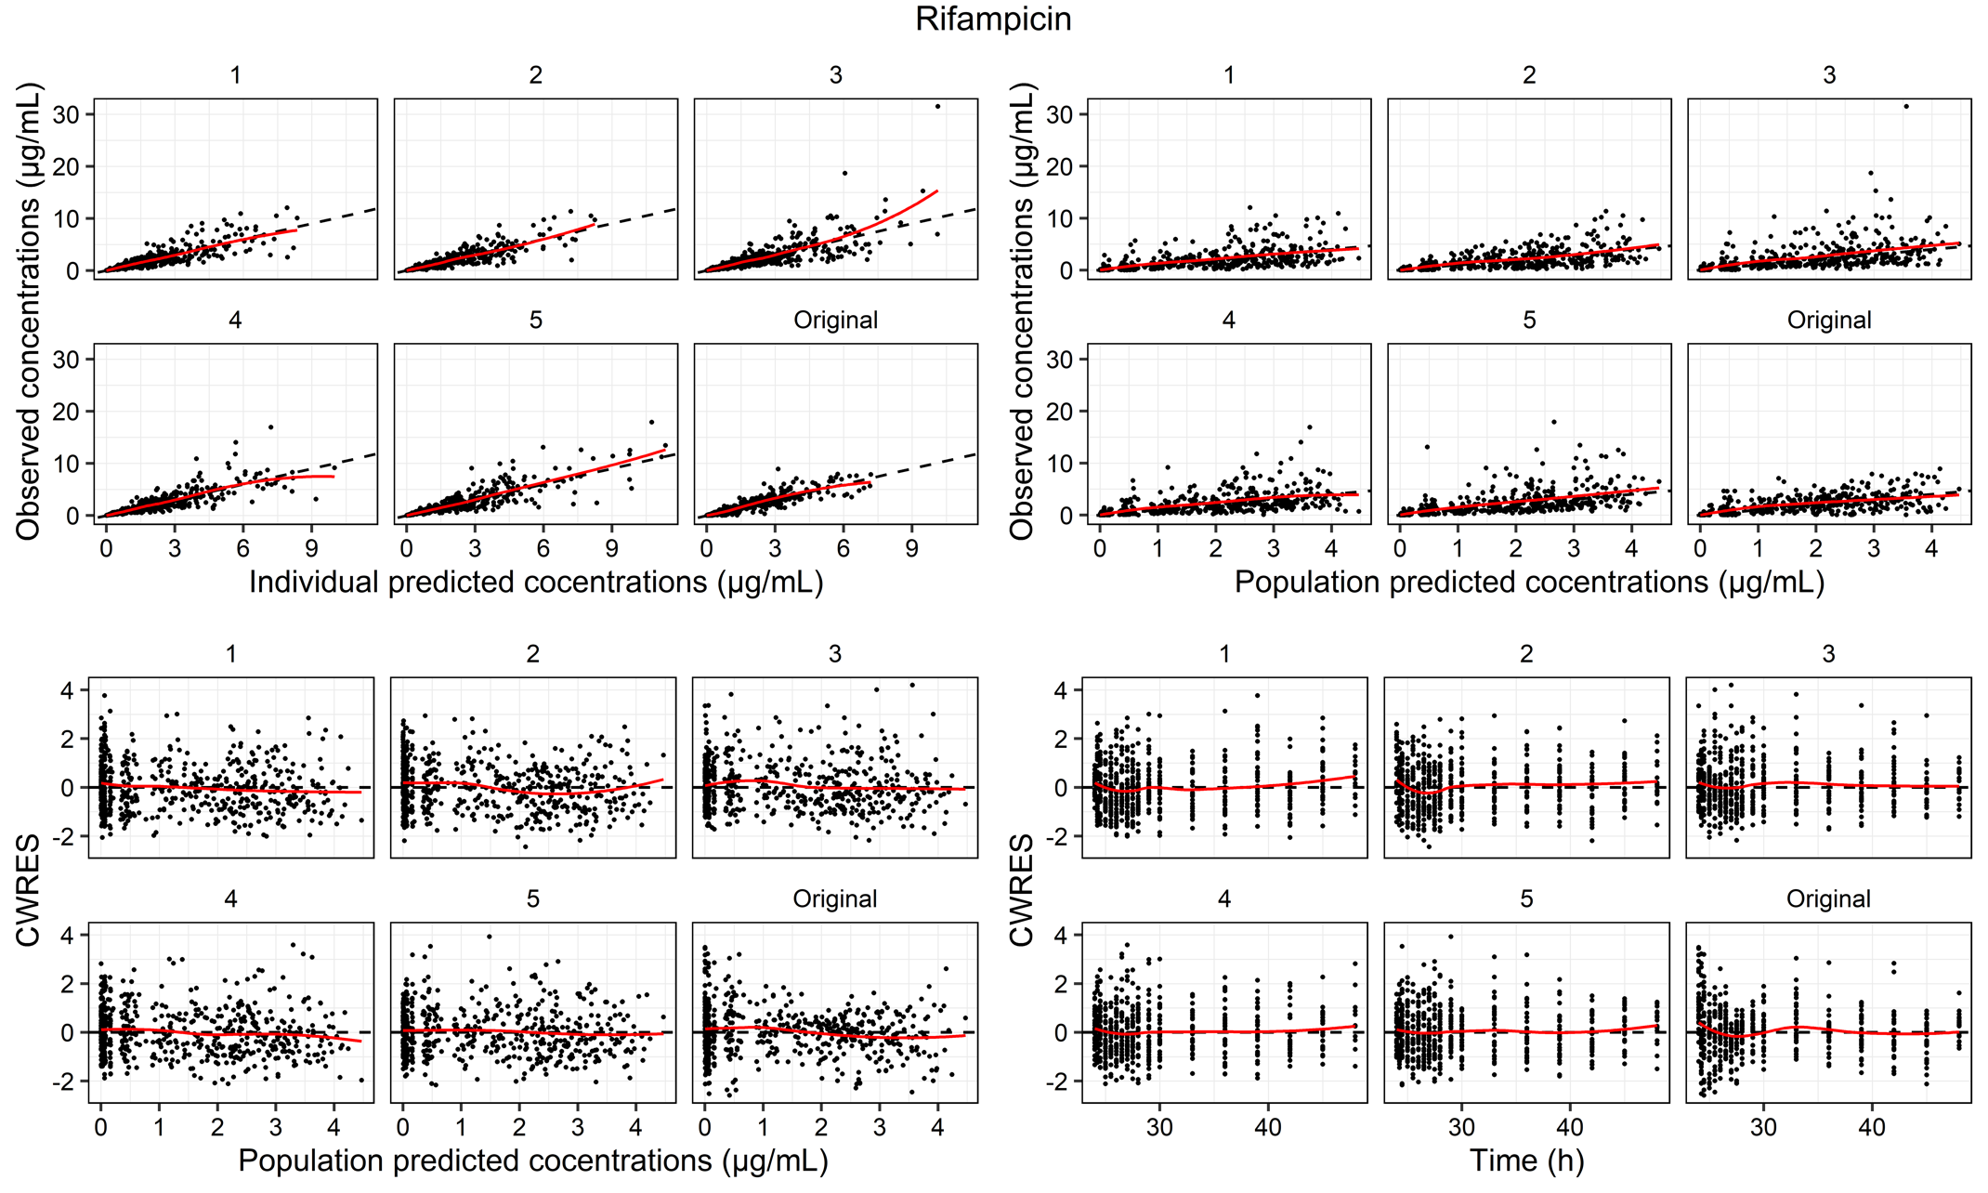

**Figure S4:** Mirror plots of rifampicin with the final model. Individual observed concentrations vs population predicted and individual predicted concentrations. Conditional weighed residuals (CWRES) vs population predicted concentrations and Time.

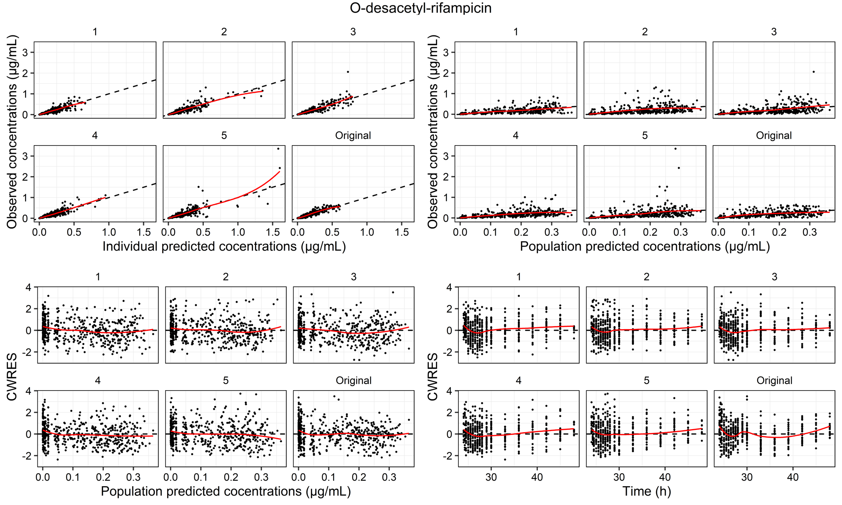

**Figure S4 continuation:** Mirror plots of 25-O-desacetly-Rifampicin with the final model. Individual observed concentrations vs population predicted and individual predicted concentrations. Conditional weighed residuals (CWRES) vs population predicted concentrations and Time.

Code file of Rifampicin and O-desacetyl-rifampicin model

$PROBLEM

$INPUT ID TIME ; hour

AMT ; mmol

SS II DV ; nmol/mL

MDV CMT WEIGHT ; Kg

HEIGHT ; meters

AGE ; years

HIV SEX

$DATA RIF&DESRIF_21_07_13_l2_mol.csv IGNORE=@

$SUBROUTINE ADVAN6 TOL=6

$MODEL NCOMP=6

$PK

IF (SEX.EQ.0) FFM=(42.92*(HEIGHT**2)*WEIGHT)/((HEIGHT**2)*30.93+WEIGHT)

IF (SEX.EQ.1) FFM=(37.99*(HEIGHT**2)*WEIGHT)/((HEIGHT**2)*35.98+WEIGHT)

F1=1*EXP(ETA(4))

CL=THETA(1)*((WEIGHT/55.7)**0.75)*EXP(ETA(1))

V=THETA(2)*(WEIGHT/55.7)*EXP(ETA(6))

FMET=THETA(3)*EXP(ETA(2))

CLM=THETA(4)*((WEIGHT/55.7)**0.75)*EXP(ETA(5))

VM=THETA(6)*(WEIGHT/55.7)*EXP(ETA(7))

S2=V/1000

S3=VM/1000

;PK model

MTT=THETA(5)*EXP(ETA(3))

NN=3

KTR=((NN+1)/MTT)

KA=KTR

$DES

DADT(1)=-KA*A(1)

DADT(2)=KTR*A(6)-(CL*(1-FMET)/V)*A(2)-(CL*FMET/V)*A(2)

DADT(3)=(CL*FMET/V)*A(2)-(CLM/VM)*A(3)

DADT(4)=KA*A(1)-KTR*A(4)

DADT(5)=KTR*A(4)-KTR*A(5)

DADT(6)=KTR*A(5)-KTR*A(6)

$ERROR

IF(CMT.EQ.2) THEN

IPRED=A(2)/S2

EPSrif=((IPRED*EPS(1))+EPS(3))*EXP(ETA(9))

Y=IPRED+EPSrif

END IF

IF(CMT.EQ.3) THEN

IPRED=A(3)/S3

EPSdesrif=((IPRED*EPS(2))+EPS(4))*EXP(ETA(8))

Y=IPRED+EPSdesrif

END IF

IF (CMT.EQ.2) STRT=2

IF (CMT.EQ.3) STRT=3

$THETA (0,35.2446) ; CL

(0,107.724) ; V

1 FIX ; Fmet

(0,368.409) ; CLM

(0,1.13401) ; MTT

(0,226.079) ; VM

$OMEGA BLOCK(2)

0.0701452 ; CL_

-0.0707649 0.139866 ; FMET_

$OMEGA 0.248705 ; MTT_

0.199309 ; F

0 FIX ; clm

0 FIX ; V_

0.337316 ; vm

0.116391 ; ruv-derif

0.0408906 ; ruv-rif

$SIGMA 0.188939 ; prop

0.118984 ; prop-desrif

$SIGMA 1.84976E-005 ; add

3.20746E-006 ; add-desrif

$ESTIMATION METHOD=1 INTER MAXEVAL=99999 SIGL=6 NSIG=2 PRINT=1 NOABORT

$COVARIANCE UNCONDITIONAL

;$SIMULATION (20030521) ONLYSIM SUBPROBLEMS=1000

$TABLE

Table S1: Final pharmacokinetics parameters of only rifampicin (RIF) model

|  |  |  |
| --- | --- | --- |
|  | Fixed effects | Randon effects |
| Parameters | Typical value (RSE) | IIV  w2 (RSE) |
| CL/F (L/h) | 35.6 (10.1 %) | 26.5 % (10.6 %) |
| V/F (L) | 110 (9.1 %) |  |
| MTT (h) | 1.14 (8.3 %) | 45.8 % (8.6 %) |
| F | ---- | 46.2 % (11.5 %) |
| nn | 3 (fix) |  |
| RUV of RIF |  | 14.4 % (35 %) |
| Residual error (e) |  | s2 (RSE) |
| RIF proportional |  | 44.7 % (7.6 %) |
| RIF additive  (nmol/mL)2 |  | 1.20e-5 (26.3 %) |

|  |  |
| --- | --- |
| Ka = Ktr = (nn+1)/MTT |  |
|  |  |

WT: Weight. WT median = 55.7 Kg. RSE: residual standard error. IIV: inter-individual variability. MTT: mean transit time. nn: number of absorption compartment transit. Ka: RIF absorption constant rate. Ktr: RIF transit absorption constant rate. V/F and Vm/F∙Fm: RIF and desRIF apparent volume of distribution. CL/F and CLm/F∙Fm: RIF and desRIF apparent clearance, Fm: fraction of CL/F converted into desRIF. F: bioavailability. RUV: residual unexplained variability. h and e random variables with mean = 0 and variance w2 and s2.

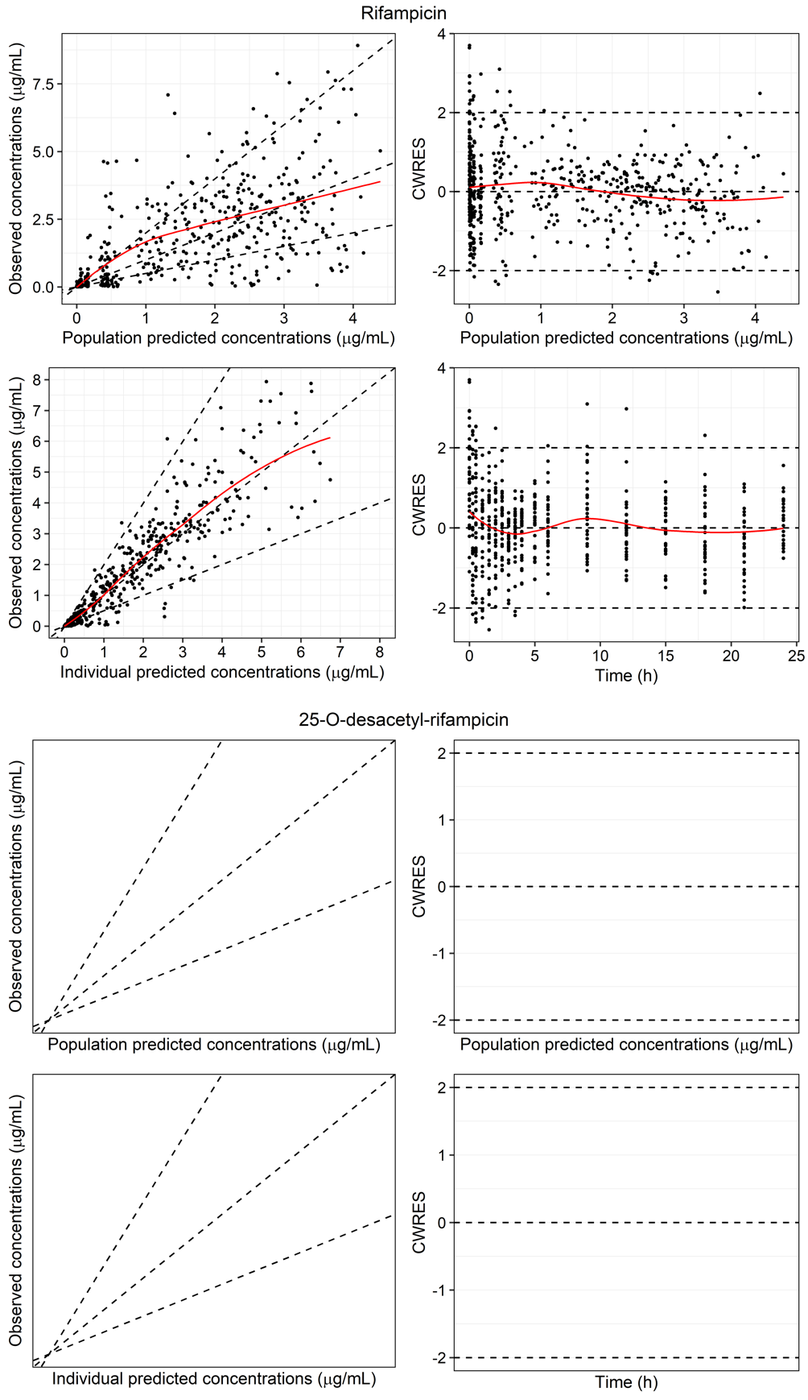

**Figure S5:** Goodness of fit plot of rifampicin (RIF). Observed concentrations (g/mL) over population and individual predictions (right). Conditional weighted residuals (CWRES) over population predictions and time (left). Red line: trend line, dashed lines: identity and 2- and 0.5-times identity in the right plots. 0, 2 and -2 CWRES in left plots.

Table S2: Pharmacokinetics parameters of the rifampicin (RIF) and 25-O-desacetil-rifampicin (desRIF) model included of Seng et al., 2015[8] PK model as prior.

|  |  |  |
| --- | --- | --- |
| Parameters | Typical value (RSE) | IIV  w2 (RSE) |
| CL/F (L/h) | 10.3 (0.3 %) | 26.5 % (10.6 %) |
| V/F (L) | 31.5 (4.7 %) |  |
| MTT (h) | 1.13 (9.0 %) | 49.9 % (7.8 %) |
| Frel | 0.292 (10.0 %) | 44.6 % (10.7 %) |
| nn | 3 (fix) |  |
| Fm | ---- | 37.4 % (15.8 %) |
| CLm/FFm (L/h) | 108 (5.5 %) |  |
| Vm/FFm (L) | 66.1 (12.2 %) | 58.1 % (22.0 %) |
| Qm/FFm (L/h) | 0 FIX |  |
| Vpm/FFm (L/h) | 0 FIX |  |
| Correlation w2  CL/F - Fm |  | 71.5 % (2.29 %) |
| RUV of RIF |  | 20.4 % (38.0 %) |
| RUV of desRIF |  | 34.1 % (28.4 %) |
| Residual error (e) |  | s2 (RSE) |
| RIF proportional |  | 43.5 % (8.5 %) |
| RIF additive  (nmol/mL)2 |  | 1.85E-5 (38.6 %) |
| desRIF proportional |  | 34.5 % (10.1 %) |
| desRIF additive  (nmol/mL)2 |  | 3.21E-6 (15.7 %) |

|  |  |
| --- | --- |
| Ka = Ktr = (nn+1)/MTT |  |
|  |  |
|  |  |
|  |  |

WT: Weight, WT median = 55.7 Kg. RSE: residual standard error. IIV: inter-individual variability. MTT: mean transit time. nn: number of absorption compartment transit. Ka: RIF absorption constant rate. Ktr: RIF transit absorption constant rate. V/F and Vm/F∙Fm: RIF and desRIF apparent volume of distribution. CL/F and CLm/F∙Fm: RIF and desRIF apparent clearance, Fm: fraction of CL/F converted into desRIF, Frel: relative bioavailability. RUV: residual unexplained variability. h and e random variables with mean = 0 and variance w2 and s2.

Table S3: Pharmacokinetics parameters of the rifampicin (RIF) and 25-O-desacetil-rifampicin (desRIF) model included of Schipani et al., 2016[9] PK model as prior.

|  |  |  |
| --- | --- | --- |
| Parameters | Typical value (RSE) | IIV  w2 (RSE) |
| CL/F (L/h) | 23.9 (0.3 %) | 26.5 % (10.6 %) |
| V/F (L) | 73.1 (4.7 %) |  |
| MTT (h) | 1.13 (9.0 %) | 49.9 % (7.8 %) |
| Frel | 0.678 (10.0 %) | 44.6 % (10.7 %) |
| nn | 3 (fix) |  |
| Fm | ---- | 37.4 % (15.8 %) |
| CLm/FFm (L/h) | 250 (5.5 %) | 1.0 % (---) |
| Vm/FFm (L) | 153 (12.2 %) | 58.1 % (22.0 %) |
| Correlation  CL/F - Fm |  | 71.5 % (2.29 %) |
| RUV of RIF |  | 20.2 % (38.4 %) |
| RUV of desRIF |  | 34.1 % (28.4 %) |
| Residual error (e) |  | s2 (RSE) |
| RIF proportional |  | 43.5 % (8.5 %) |
| RIF additive  (nmol/mL)2 |  | 1.85E-5 (39.2 %) |
| desRIF proportional |  | 34.5 % (10.1 %) |
| desRIF additive  (nmol/mL)2 |  | 3.21E-6 (15.7 %) |

|  |  |
| --- | --- |
| Ka = Ktr = (nn+1)/MTT |  |
|  |  |
|  |  |
|  |  |

WT: Weight. WT median = 55.7 Kg. RSE: residual standard error. IIV: inter-individual variability. MTT: mean transit time. nn: number of absorption compartment transit. Ka: RIF absorption constant rate. Ktr: RIF transit absorption constant rate, V/F and Vm/F∙Fm: RIF and desRIF apparent volume of distribution. CL/F and CLm/F∙Fm: RIF and desRIF apparent clearance, Fm: fraction of CL/F converted into desRIF, Frel: relative bioavailability. RUV: residual unexplained variability. h and e random variables with mean = 0 and variance w2 and s2.

Table S4: Pharmacokinetics parameters of the rifampicin (RIF) and 25-O-desacetil-rifampicin (desRIF) model included of Wilkins et al. 2008[10] FDC PK model as prior.

|  |  |  |
| --- | --- | --- |
| Parameters | Typical value (RSE) | IIV  w2 (RSE) |
| CL/F (L/h) | 19.2 (0.1 %) | 28.2 % (12.9 %) |
| V/F (L) | 53.2 (0.1 %) |  |
| MTT (h) | 1.14 (9.0 %) | 50 % (7.9 %) |
| Frel | 0.499 (9.3 %) | 44.5 % (10.6 %) |
| nn | 3 (fix) |  |
| Fm | ---- | 38.7 % (17.1 %) |
| CLm/FFm (L/h) | 201 (5.8 %) |  |
| Vm/FFm (L) | 124 (12.6 %) | 58.1 % (21.7 %) |
| Correlation w2  CL/F - Fm |  | 73.8 % (2.95 %) |
| RUV of RIF |  | 20.8 % (36.8 %) |
| RUV of desRIF |  | 34.4 % (27.6 %) |
| Residual error (e) |  | s2 (RSE) |
| RIF proportional |  | 43.2 % (8.5 %) |
| RIF additive  (nmol/mL)2 |  | 2.05E-5 (39.3 %) |
| desRIF proportional |  | 34.4 % (10.0 %) |
| desRIF additive  (nmol/mL)2 |  | 3.28E-6 (15.4 %) |

|  |  |
| --- | --- |
| Ka = Ktr = (nn+1)/MTT |  |
|  |  |
|  |  |
|  |  |

WT: Weight. WT median = 55.7 Kg. RSE: residual standard error. IIV: inter-individual variability. MTT: mean transit time. nn: number of absorption compartment transit. Ka: RIF absorption constant rate. Ktr: RIF transit absorption constant rate, V/F and Vm/F∙Fm: RIF and desRIF apparent volume of distribution. CL/F and CLm/F∙Fm: RIF and desRIF apparent clearance, Fm: fraction of CL/F converted into desRIF, Frel: relative bioavailability. RUV: residual unexplained variability. h and e random variables with mean = 0 and variance w2 and s2. FDC: Fixed dose combined formulation.

Table S5: Pharmacokinetics parameters of the rifampicin (RIF) and 25-O-desacetil-rifampicin (desRIF) model included of Milán-Segovia et al., 2013 [11] PK model as prior.

|  |  |  |
| --- | --- | --- |
| Parameters | Typical value (RSE) | IIV  w2 (RSE) |
| CL/F (L/h) | 8.17 (0.1 %) | 26.5 % (10.6 %) |
| V/F (L) | 25 (4.7 %) |  |
| MTT (h) | 1.13 (9.0 %) | 49.9 % (7.8 %) |
| Frel formulation A | 0.497 (10 %) | 44.7 % (10.6 %) |
| Frel reference | 0.232 (10 %) |  |
| Nn | 3 (fix) |  |
| Fm | ---- | 37.4 % (15.7 %) |
| CLm/FFm (L/h) | 85.3 (5.5 %) |  |
| Vm/FFm (L) | 52.3 (12.2 %) | 58.1 % (21.9 %) |
| Correlation w2  CL/F - Fm |  | 71.3 % (2.28 %) |
| RUV of RIF |  | 20.2 % (37.9 %) |
| RUV of desRIF |  | 34.1 % (28.5 %) |
| Residual error (e) |  | s2 (RSE) |
| RIF proportional |  | 43.5 % (8.4 %) |
| RIF additive  (nmol/mL)2 |  | 1.84E-5 (38.9 %) |
| desRIF proportional |  | 34.5 % (10.1 %) |
| desRIF additive  (nmol/mL)2 |  | 3.20E-6 (15.8 %) |

|  |  |
| --- | --- |
| Ka = Ktr = (nn+1)/MTT |  |
|  |  |
|  |  |
|  |  |

WT: Weight. WT median = 55.7 Kg. Frel reference: Rifater, Sanofi-Aventis, Mexico. RSE: residual standard error. IIV: inter-individual variability. MTT: mean transit time. nn: number of absorption compartment transit. Ka: RIF absorption constant rate. Ktr: RIF transit absorption constant rate, V/F and Vm/F∙Fm: RIF and desRIF apparent volume of distribution. CL/F and CLm/F∙Fm: RIF and desRIF apparent clearance, Fm: fraction of CL/F converted into desRIF, Frel: relative bioavailability. RUV: residual unexplained variability. h and e random variables with mean = 0 and variance w2 and s2.

References

1. Nardotto, G.H.B.; Bollela, V.R.; Rocha, A.; Della Pasqua, O.; Lanchote, V.L. No Implication of HIV Coinfection on the Plasma Exposure to Rifampicin, Pyrazinamide, and Ethambutol in Tuberculosis Patients. *Clinical and Translational Science* **2022**, *15*, 514–523, doi:10.1111/cts.13169.

2. Weiner, M.; Peloquin, C.; Burman, W.; Luo, C.-C.; Engle, M.; Prihoda, T.J.; Kenzie, W.R.M.; Bliven-Sizemore, E.; Johnson, J.L.; Vernon, A. Effects of Tuberculosis, Race, and Human Gene SLCO1B1 Polymorphisms on Rifampin Concentrations. *Antimicrob. Agents Chemother.* **2010**, 54, 4192–4200, doi:10.1128/AAC.00353-10.

3. Mould, D.R.; Upton, R.N. Basic Concepts in Population Modeling, Simulation, and Model-Based Drug Development—Part 2: Introduction to Pharmacokinetic Modeling Methods. *CPT Pharmacometrics Syst Pharmacol* **2013**, *2*, e38, doi:10.1038/psp.2013.14.

4. Nguyen, T.H.T.; Mouksassi, M.-S.; Holford, N.; Al‐Huniti, N.; Freedman, I.; Hooker, A.C.; John, J.; Karlsson, M.O.; Mould, D.R.; Ruixo, J.J.P.; et al. Model Evaluation of Continuous Data Pharmacometric Models: Metrics and Graphics. *CPT: Pharmacometrics & Systems Pharmacology* **2017**, *6*, 87–109, doi:10.1002/psp4.12161.

5. Bergstrand, M.; Hooker, A.C.; Wallin, J.E.; Karlsson, M.O. Prediction-Corrected Visual Predictive Checks for Diagnosing Nonlinear Mixed-Effects Models. *The AAPS Journal* **2011**, *13*, 143–151, doi:10.1208/s12248-011-9255-z.

6. Yano, Y.; Beal, S.L.; Sheiner, L.B. Evaluating Pharmacokinetic/Pharmacodynamic Models Using the Posterior Predictive Check. *J Pharmacokinet Pharmacodyn* **2001**, *28*, 171–192, doi:10.1023/A:1011555016423.

7. Comets, E.; Brendel, K.; Mentré, F. Computing Normalised Prediction Distribution Errors to Evaluate Nonlinear Mixed-Effect Models: The Npde Add-on Package for R. *Computer Methods and Programs in Biomedicine* **2008**, *90*, 154–166, doi:10.1016/j.cmpb.2007.12.002.

8. Seng, K.-Y.; Hee, K.-H.; Soon, G.-H.; Chew, N.; Khoo, S.H.; Lee, L.S.-U. Population Pharmacokinetics of Rifampicin and 25-Deacetyl-Rifampicin in Healthy Asian Adults. *J Antimicrob Chemother* **2015**, *70*, 3298–3306, doi:10.1093/jac/dkv268.

9. Schipani, A.; Pertinez, H.; Mlota, R.; Molyneux, E.; Lopez, N.; Dzinjalamala, F.K.; van Oosterhout, J.J.; Ward, S.A.; Khoo, S.; Davies, G. A Simultaneous Population Pharmacokinetic Analysis of Rifampicin in Malawian Adults and Children. *Br J Clin Pharmacol* **2016**, *81*, 679–687, doi:10.1111/bcp.12848.

10. Wilkins, J.J.; Savic, R.M.; Karlsson, M.O.; Langdon, G.; McIlleron, H.; Pillai, G.; Smith, P.J.; Simonsson, U.S.H. Population Pharmacokinetics of Rifampin in Pulmonary Tuberculosis Patients, Including a Semimechanistic Model To Describe Variable Absorption. *Antimicrob Agents Chemother* **2008**, *52*, 2138–2148, doi:10.1128/AAC.00461-07.

11. Segovia, R.C.M.; Ramírez, A.M.D.; Cook, H.J.; Aquino, M.M.; Pérez, M.V.; Brundage, R.C.; Moreno, S.R. Population Pharmacokinetics of Rifampicin in Mexican Patients with Tuberculosis. *Journal of Clinical Pharmacy and Therapeutics* **2013**, *38*, 56–61, doi:10.1111/jcpt.12016.